How to view and change DB password in IMC

**Labels: HPE Comware Switch**

**Requirement:**

Sometimes you don't have access to Database and you want the **sa** password or want to modify the sa password.

**Solution:**

We can use MS CMD to view or modify the Database Password.

**Configuration:**

You would need to **go to the deploy folder under iMC** or add the path while executing the command

**pwdmgr.bat -query** database_ip **config_db** sa

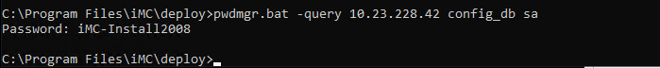

If required to change the sa password, then execute below cautiously.

C:\Program Files\iMC\deploy>**pwdmgr.bat -modify** database_ip **config_db** sa *****

* is new password

**Verification:**

Use same command under deploy folder to see the change taking effect.

**pwdmgr.bat -query** database_ip **config_db** sa

Tags: HPE Comware Switch, unmanaged, #imc